The Honorable Gavin Newsom
Governor State of California
State Capitol
Sacramento, CA 95814

RE: Recommendations for the Master Plan for Aging

Dear Governor Newsom:

Thank you for your commitment to prioritizing the health and well-being of older Californians. California Food Policy Advocates (CFPA) strongly supports your efforts to establish a Master Plan for Aging and we look forward to contributing to the development of its design and implementation. As an organization with a wealth of experience advocating policies to increase low-income Californians’ access to nutritious, affordable food, we write to offer our recommendations for how the plan can address the nutritional needs of California’s growing aging population, allowing them to age in place with dignity.

CFPA is a statewide policy and advocacy organization dedicated to improving the health and well-being of low-income Californians. We are part of a larger movement taking place across California to transform our state into a place where all people and communities have equitable access to health, prosperity, opportunity and empowerment. As a trusted partner and voice in this movement, we help advance the ambitious vision we share with our partners by advocating smart, progressive policies that dismantle the barriers standing in the way of more equitable access to healthy, affordable food. For over twenty-six years, we have used evidence-based policy, advocacy, and research to support the nutritional needs of California’s critically under-resourced and disenfranchised residents. Although we have helped bring critical support to tens of millions of Californians, our state still has much to do to help put nutritious food on the table for its aging population.

We need a Master Plan for Aging that reduces the growing number of older Californians who cannot consistently afford or access enough nutritious food.

While food insecurity has steadily been declining among California’s general population, the number of older Californians with limited, uncertain, or inconsistent access to the quality and quantity of food they need to live a healthy life continues to grow at an alarming rate. Based on data from the UCLA Center for Health Policy Research, nearly forty percent of low-income Californians over the age of sixty are food insecure, representing a twenty-one percent increase in the last fifteen years. A lack of sustained access to enough nutritious, affordable food is tied to an increased likelihood of chronic disease, hospitalizations, poorer disease management, mental health problems, as well as increased health care spending.,,,, It is critical that we design a Master Plan for Aging that helps reverse this harmful trend.

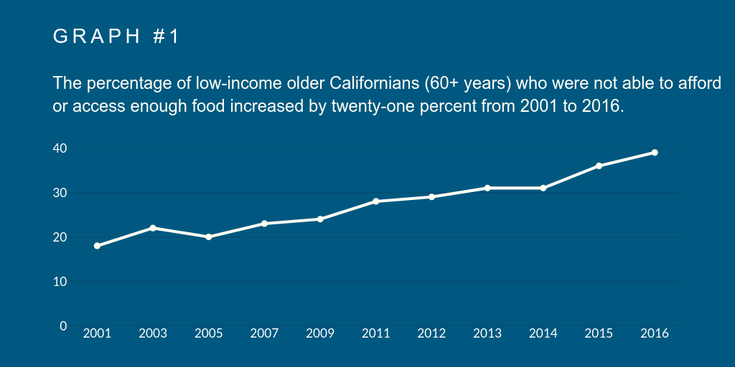

Note: Data for this graph was drawn from the 2001-2016 California Health Interview Survey (CHIS). CHIS measures food insecurity at the household level through the Six-Item Short Form of the Food Security Survey Module among Californians living at or below 200% of the Federal Poverty Level. For more information about CHIS visit: http://healthpolicy.ucla.edu/chis/Pages/default.aspx.

Several factors are contributing to higher food insecurity among California's older adults. Income inequality has risen and as the gap between rich and poor has widened, many older adults living on fixed incomes are struggling to afford California’s rising costs of living. Rents are already high, but continue to increase. Out-of-pocket health care costs are also going up. As the cost of meeting basic needs continues to rise, food is often one of the first things to be dropped from older adults’ fixed incomes. As older adults are forced into food insecurity, their risk for chronic illnesses goes up. Declining health only further drains household budgets, contributing to a vicious cycle of poverty and poor health outcomes. In addition to these factors, racial and ethnic disparities continue to contribute to the rise of food insecurity among older Californians.

California’s older adults are becoming more racially and ethnically diverse and food insecurity is correlated with race and ethnicity. White Americans have the lowest rates of food insecurity followed by other ethnic minorities, Latinx, and Black Americans. These communities face systemic injustices such as punitive policing, patterns of racial/ethnic segregation, and employment and earnings gaps that impact their ability to achieve wealth, prosperity, and food security.,, Beyond racial, ethnic, and socioeconomic disparities, California’s aging population is impacted by additional factors that make older adults particularly susceptible to food insecurity.

Although having inadequate financial resources is a major cause of food insecurity, older adults often face additional, unique challenges that limit their ability to obtain, prepare, and/or eat nutritious food. Many older Californians lack community and/or family support, and social isolation limits older adults’ ability to access nutrition resources. Mobility issues due to physical constraints, functional limitations, and lack of transportation also limit older adults from picking up food from grocery stores and preparing food safely at home. Poor fitting dentures and oral pain can also play a role in increasing the risk of food insecurity. California’s Master Plan for Aging must take into account these diverse factors and target assistance to those Californians who are struggling the most.

RECOMMENDATION 1:
The Master Plan for Aging must address rising economic insecurity among older adults and seek to end the disparities that perpetuate hunger and undermine health, including increasing the state’s supplementary payment to the Supplemental Security Income/State Supplementary Payment for low-income older adults and people with disabilities.

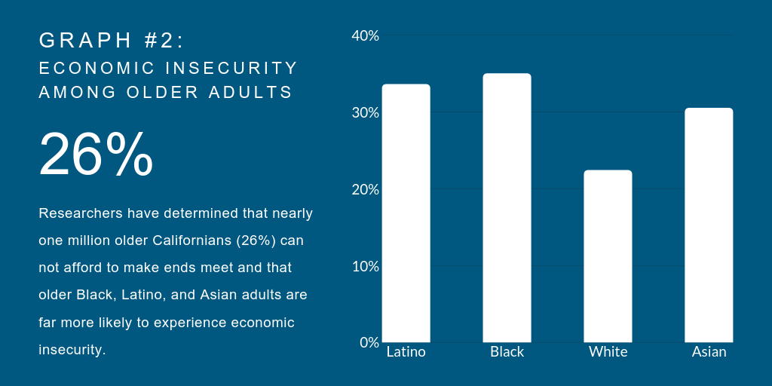

Note: Data for this graph was drawn from the 2015 Elder Index Demographics Dashboard. The Elder Index™ measures the actual cost of basic necessities for older adults in each of California's 58 using data from the California Health Interview Survey (CHIS). For more information about the Elder Index™ visit: http://healthpolicy.ucla.edu/programs/health-disparities/elder-health/Pages/elder-index-2011.aspx

An essential goal of California’s Master Plan for Aging must be improving the economic security of our aging population. Researchers have determined that nearly one million older Californians cannot afford to make ends meet — they lack sufficient income to pay for a minimum level of housing, food, health care, transportation and other basic expenses, as measured by the Elder Economic Security Standard™ Index (Elder Index™). Unfortunately, economic insecurity is most severe for certain communities. Older Black, Latinx, and Asian adults are more likely to experience economic insecurity in California because of systemic injustices they have confronted throughout their lives.¹⁸ These are disparities the Master Plan for Aging cannot ignore. The Master Plan for Aging should advance policies aimed at correcting the systemic imbalances and injustices that perpetuate poverty, hunger, and poor health, including increasing the state's supplement to the Supplemental Security Income/State Supplementary Payment grants for low-income older adults and people with disabilities. State policymakers deeply cut the SSP portion of the grant during and following the Great Recession and also eliminated the annual statutory cost-of-living adjustment. These actions significantly compromised the ability of over one million Californians, including hundreds of thousands of older adults, to make ends meet. There are changes within the state’s control, including increasing the SSP portion of the grant to (at least) its pre-recession level as well as restoring the annual state COLA, that should be taken to help accelerate the arrival of an age of equity and inclusion.

RECOMMENDATION 2:
The Master Plan for Aging should include actionable strategies to maximize the impact and increase the reach of CalFresh for older adults.

Although several factors play a role in increasing the risk of food insecurity among older adults, increasing access to CalFresh (commonly known as food stamps and nationally as the Supplemental Nutrition Assistance Program or SNAP) remains one of the most promising solutions to reducing food insecurity among California's diverse aging population. Forty years of research and experience show that CalFresh helps reduce food insecurity and improve economic stability for Californians. The program supplements household food budgets by providing 100 percent federally-funded cash-equivalent benefits delivered on a debit like card that can be used exclusively for the purchase of food at participating retailers. Although the minimum monthly benefit is $16 as of October 1st, the average CalFresh older adult (60+) receives about $137 a month to help buy groceries. In contrast to other federal nutrition programs for older adults which have budgetary constraints, CalFresh is a federal entitlement program. As such, the federal government has a binding obligation to provide benefits to all individuals that qualify and eligible recipients have legal recourse if the obligation is not fulfilled. There is a tremendous opportunity for California to reduce food insecurity among older adults by increasing enrollment in CalFresh, especially considering that 81 percent of likely-eligible older adults in the state are enrolled.²⁰

Although CalFresh has the ability to reduce food insecurity, the vast majority of older adults eligible for the program are not participating. Nationally, about 42 percent of eligible older adults participate in SNAP, but in California only 19 percent of eligible older adults are enrolled. California ranks among the bottom five states for enrolling eligible individuals in SNAP and ranks last in the nation at enrolling eligible older adults.²² Research findings suggest that poor understanding of the eligibility criteria and a complex and overly burdensome application and enrollment process contribute to the low enrollment.

The California Department of Social Services has been advancing solutions aimed at helping enroll more eligible older adults into the program. As a result, participation in CalFresh has increased significantly for that population. Mathematica reports that the CalFresh caseload for older adults nearly tripled between 2008 and 2015. Over that same time period, California was one of only six states in which participation grew by over 150 percent. However, even with these improvements, the average percentage of older adults accessing CalFresh benefits is nearly 7 percentage points lower than the next lowest state. There is a huge opportunity for California to extend its reach to help enroll more older adults onto the program.

In more recent years, the state has enacted additional policy solutions, and these successes must be built upon. In 2017, CDSS was approved for two federal waiver requests: the Elderly Simplified Application Project (ESAP) and Standard Medical Deduction (SMD) demonstration project. The ESAP waiver has helped simplify the application and recertification process for households with only elderly (age 60 or older) and/or disabled household members that have no earned income. The SMD demonstration is enabling households with at least one elderly and/or disabled member to increase their monthly CalFresh benefits if they can prove that they have monthly medical expenses in excess of $35. In 2018, California also expanded eligibility for CalFresh to individuals receiving Social Security Income (SSI), and nearly 500,000 SSI clients (older adults and people with disabilities) became CalFresh-eligible for the first time. In 2019, CDSS began contracting with the California Department of Aging and the California Department of Rehabilitation to help newly eligible Californians apply for the program. CDSS also strengthened its partnership with the Social Security Administration to streamline the CalFresh application process for individuals applying for SSI at the Social Security Administration office. In addition, CDSS expanded its CalFresh outreach contract with Code for America statewide to leverage their mobile-friendly application tool, GetCalFresh.org, which cuts down the time required to apply for CalFresh to an average of just eight minutes. Combined, these efforts have helped enroll over 200,000 individuals onto the CalFresh program in the last year and will hopefully aid in increasing retention in the program among older adult participants.

Although California is making significant progress in increasing access to CalFresh for older adults, these strategies alone are not sufficient to meet the needs of California’s rapidly growing older adult population. The state should build upon existing efforts and pursue the following additional evidence-based strategies to help enroll more likely-eligible older adults onto CalFresh and to keep them enrolled:

- Provide all older adults the option to complete the CalFresh application and recertification process online and by telephone, so they don’t have to make a trip to the CalFresh office or mail in cumbersome and sensitive documentation: After completing a CalFresh application, federal law requires applicants to participate in an interview with an eligibility worker. Although local CalFresh offices are directed to prioritize interviews over the phone, only 20 counties in California allow the applicant to complete the interview, including the required signature, solely by phone. Offering complete access by phone, including telephonic signature, was the number one recommendation to improve access put forth by the SSI CalFresh Expansion Customer Experience Workgroup. Despite that strong recommendation from Workgroup members, including CDSS, CWDA, individual counties, and other stakeholders, the majority of counties still do not offer that service. The inability to complete the entire application process remotely imposes a challenge for older adults who face mobility and transportation challenges. California should work with counties to identify and advance solutions to provide more equitable access to CalFresh for older adults.

- Participate in all elements of the Elderly Simplified Application Project by developing a user-centered application for older adults and by eliminating the interim interview requirement to minimize the burden of the enrollment and reporting process: All eligible Californians, regardless of where they live, what language they speak, their life circumstances, or their functional limitations should be able to access CalFresh with ease. California should continue to participate in all elements of the Elderly Simplified Application Project and also develop a simplified, user-centered application for older adults that minimizes the burdens of the overall enrollment process to apply, receive, and retain benefits. The state should also seek further federal waiver authority to waive the interim reporting requirements for ESAP households, so that they may be certified for three years without the risk of falling off the program rolls due to failure to complete unnecessary paperwork.

- Support the successful roll out of the SNAP online purchasing pilot to support older adults with transportation and mobility challenges: Recognizing that transportation and mobility challenges can impede an older adult’s access to food, congress passed legislation in 2014 to pilot the use of online ordering and payment with SNAP before expanding the pilot nationally. In early 2019, the pilot launched in New York and is expected to expand within the next few months to Alabama, Iowa, Maryland, Nebraska, New Jersey, Oregon and Washington. Pending the evaluation of the pilot, online ordering and payment with SNAP will expand to additional states, including California. California should ensure that the rollout of the pilot will benefit older adults statewide.

- Invest in innovative pilots that increase CalFresh benefits for older adults: Although CalFresh makes a significant impact on increasing access to food for older adults, the program falls short of meeting all of the nutritional needs of participating older adults. Benefit allotments for the program are determined based on an outdated federal funding model and do not account for the true cost of living in California. California should continue to pilot innovative strategies, such as the CalFresh Fruit and Vegetable EBT Pilot and California’s Standard Medical Deduction Demonstration Project, to help better meet the nutritional needs of older adults through increased CalFresh benefit levels.
- Support outreach efforts and increase interdepartmental collaboration to support enrollment into the program: New CalFresh outreach partnerships formed as part of the expansion of CalFresh to SSI recipients have been widely successful. Collaboration between CDSS, the California Department of Aging, the California Department of Rehabilitation, and GetCalFresh among others has helped provide necessary information and application assistance to thousands of older adults. Building upon the success of the expansion, the state should continue to leverage federal and state dollars to help the state’s growing aging population enroll onto the program.

Strategies to improve CalFresh access may require additional state funding. The state plan should commit to necessary increased budgetary requirements. In the long term, these investments will help the state not only reduce food insecurity, but also cut health care costs for our aging population. Research has shown that increasing access to SNAP/CalFresh can reduce health care utilization and costs for older adults. Participation in SNAP has been estimated to reduce an older adult’s (60+ years) likelihood of admission into a hospital by 14%, into a nursing home by 23 percent, and to save $2,100 in annual healthcare expenses per person enrolled.

RECOMMENDATION 3:
Beyond CalFresh, the Master Plan for Aging should include recommendations to scale up the impact of California’s other federally-funded nutrition programs for older adults.

In addition to CalFresh, California administers a number of federal nutrition programs, identified below, that focus on meeting the nutritional needs of older adults. Although the programs share a similar goal and target similar populations, they are administered by different government agencies, including:
- The California Department of Social Services (administers CalFresh and the Commodity Supplemental Food Program);
- The California Department of Aging (administers congregate and home-delivered meals);
- The California Department of Food and Agriculture (administers the Senior Farmers Market Nutrition Program);
- The California Department of Education (administers the Child and Adult Care Food Program).

Each of these state agencies holds valuable knowledge about opportunities to scale up access to these programs. As the Master Plan for Aging is developed, these agencies and local program administrators should be consulted for recommendations to support greater cross-program collaboration and to help augment the collective impact of California’s federal nutrition programs.
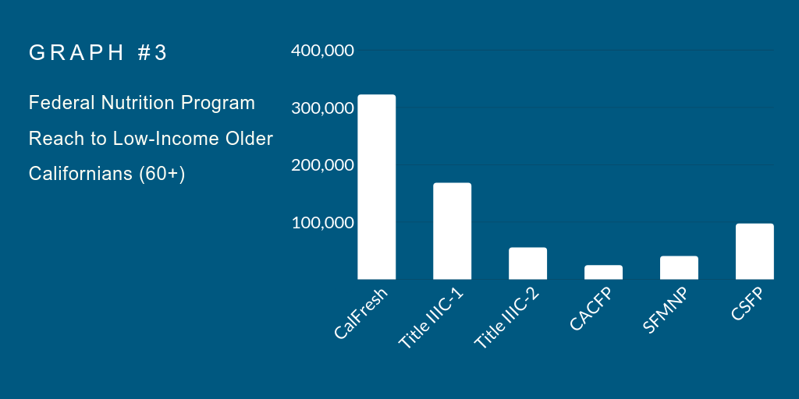

Note: Program participation data for CalFresh, Title IIIC-1 (congregate meals), Title IIIC-2 (home-delivered meals), SFMNP (senior farmers' market nutrition program), and CSFP (commodity supplemental food program) are drawn from the most recently available program participation data from administering bodies. Here, “Low-income” is defined as income below 200% of the official federal poverty measure.

- The Congregate Nutrition Program (Title IIIC-1): Every day, thousands of older Californians receive a nutritious meal at a senior center or other congregate meal site through the Congregate Nutrition Program (Title IIIC-1). Participating sites receive federal funding to provide healthy meals to older adults. Although adults may eat meals for free regardless of their income level, all participants are provided the opportunity to contribute to the cost of the meal. In addition to meals and the opportunity for socialization, the program supports the provision of nutrition screenings, nutrition education, and nutrition assessment and, in some areas, nutrition counseling. In 2016, an estimated 168,086 participants were served meals through the program. Of those, over 40 percent self-identified as having an annual income below 125 percent of the federal poverty level.

- The Home-Delivered Nutrition Program (Title IIIC-2): The Home-Delivered Nutrition Services program provides funding to support the provision of meals to older individuals who are homebound. In addition to meals, participants may receive other nutrition services such as screening, education, or counseling. In 2016, an estimated 55,266 participants were served meals through the program. Of those, about 50 percent self-identified as having an annual income below 125 percent of the federal poverty level.
- The Child and Adult Care Food Program: The adult day care component of the Child and Adult Care Food Program (CACFP) is available to public or private nonprofit organizations, or certain for-profit organizations, that provide nonresidential day care services to functionally impaired adults and adults who are 60 years of age or older. Participating centers receive a cash reimbursement for meals or snacks served to adults. The reimbursement rate is based on the number of enrolled participants that are eligible for free or reduced price meals based on each participant’s income status. Adults who participate in CalFresh, the Food Distribution Program on Indian Reservations, SSI, and Medi-Cal are eligible for free meals. In California, 315 adult day care center sites are approved to operate CACFP and on an average day in California about 24,269 individuals participate in the program.

- The Senior Farmers Market Nutrition Program: Older adults whose income falls at or below 185 percent of the Federal Poverty Guidelines are eligible to receive $20 every year during the May-September growing season that they can use to purchase fresh produce at 474 participating farmers markets in California. In 2018, the program served 40,224 low-income older adults with the support of over $770,000 in federal funds. Participation in the program is limited to available funding.

- Commodity Supplemental Food Program: The Commodity Supplemental Food Program is a federal program administered by the California Department of Social Services through ten local agencies. The program provides packages of USDA approved foods to adults over the age of 60 who have incomes at or below 130 percent of the current Federal Poverty Income Guidelines. On an average month about 97,070 older adults participate in the program statewide.

RECOMMENDATION 4:
The Master Plan for Aging should include recommendations to measure the impact and reach of California’s federal nutrition programs.

California administers a number of federal nutrition programs that support older adults, but there is no governing body that collects complete data on how these programs are meeting the nutritional needs of California’s diverse aging population. Due to a lack of information, we do not know if a problem exists or to what extent. Better data is needed to help break down programmatic siloes and to create a more holistic view of older adults and their cross-program experiences. With better data, we can also monitor how these programs are reaching or not reaching specific communities. Given the state's significant investments in older adults, the state has a responsibility to know how these programs are working or not working to meet the nutritional needs of older adults. Equipping California’s policymakers and administrators with the information needed to make future decisions regarding the nutrition of California's older adults is an important first step toward inclusiveness and a more client-centric approach to delivering services.

RECOMMENDATION 5:
The Master Plan for Aging Should Commit to Pilot-Testing Innovative Approaches to Improve Older Adult’s Overall Health and Well-Being, including piloting approaches within health care.

As California attempts to develop solutions to our aging population’s diverse needs, many older Californians are still waiting to feel any relief. While Master Plans are discussed and developed, tens of thousands of Californians are struggling with limited resources to make ends meet. Too many of our most vulnerable older adults cannot afford to wait for long-term solutions. We need to continue to invest in innovative approaches that both provide temporary relief and a platform from which to learn. The Master Plan for Aging should commit to building upon the programs and solutions that we know work, but leave room for piloting and innovation to learn what we don’t yet know. This includes investigating the unique role that health care can play.

Some insurers and health care providers are beginning to offer nutrition services to their clients, including helping their clients sign up for CalFresh and arranging for home-delivered meals following a hospitalization. As California continues to help older adults age in place rather than enter a nursing home, the need for home-delivered meals will likely grow. Medicare Advantage plans recently received a “green light” from the U.S. Department of Health and Human Services to begin offering meals as a service to their Medicare clients. Some speculate that a green light for Medicaid could be next. California should explore ways to encourage Medicare Advantage plans to provide meals to older adults in need while also piloting ways in which California’s Medicaid program can better support the nutritional needs of low-income older adults.

Thank you for your consideration of our recommendations. We look forward to participating in the development of the Master Plan for Aging over the next year. If you have any questions, we can be reached at the contact information provided below.

Sincerely,

Melissa Cannon, Senior Advocate
California Food Policy Advocates
melissa@cfpa.net
209.200.8446

CC:
Secretary Mark Ghaly, MD, MPH, Secretary, California Health and Human Services Agency
Kim McCoy Wade, Acting Director, California Department of Aging

REFERENCES

UCLA Center for Health Policy Research. (2001-2016) California Health Interview Survey Data. Retrieved from https://healthpolicy.ucla.edu/chis/data/Pages/GetCHISData.aspx
Seligman, Laraia, Kushel. (2010) Food insecurity is associated with chronic disease among low-­income NHANES participants. J Nutrition, 140(2), 304–310.
Seligman, Davis, Schillinger, Wolf. (2010) Food insecurity is associated with hypoglycemia and poor diabetes self ­management in a low-­income sample with diabetes. J Health Care Poor Underserved, 21(4), 1227–1233.
Berkowitz. Seligman. Basu. (2018) Food insecurity, healthcare utilization, and high cost: A longitudinal cohort study. Am J Manag Care. 24(9):399-404.
Stuff, Janice E., Patrick H. Casey, Kitty L. Szeto, Jeffrey M. Gossett, James M. Robbins, Pippa M. Simpson, Carol Connell, and Margaret L. Bogle. 2004. “Household Food Insecurity Is Associated with Adult Health Status.” Journal of Nutrition, 134:2330–2335.
Tarasuk, Cheng, de Oliveira C, Dachner, Gundersen, Kurdyak. (2015) Association between household food insecurity and annual health care costs.CMAJ,187(14), E429-E436
Sarah Bohn; Caroline Danielson. (2016) Income Inequality and the Safety Net in California. Public Policy Institute of California. Retrieved from https://www.ppic.org/content/pubs/report/R_516SBR.pdf
Scaly CP, Gonzalez D. (2019) Housing California's Future. PPIC. Retrieved from https://www.ppic.org/wp-content/uploads/californias-future-housing-january-2019.pdf
Cubanski J, Neuman T, Damico A, Smith K. (2018) Medicare Beneficiaries’ Out-of-Pocket Health Care Spending as a Share of Income Now and Projections for the Future. Kaiser Family Foundation. Retrieved from https://www.kff.org/medicare/report/medicare-beneficiaries-out-of-pocket-health-care-spending-as-a-share-of-income-now-and-projections-for-the-future/
Fernandes SG, Rodrigues AM, Nunes C, Santos O, Gregório MJ, de Sousa RD, Dias S, Canhão H. (2018) Food Insecurity in Older Adults: Results From the Epidemiology of Chronic Diseases Cohort Study 3. Front Med (Lausanne). 12(5):203. doi: 10.3389/fmed.2018.00203.
Laurel B, Johnson H. (2015) Planning for California's Growing Senior Population. Public Policy Institute of California. Retrieved from https://www.ppic.org/publication/planning-for-californias-growing-senior-population/
United States Department of Agriculture. (2017) Key Statistics & Graphics. Accessed from: https://www.ers.usda.gov/topics/food-nutrition-assistance/food-security-in-the-us/key-statistics-graphics.aspx#householdtype
White. (2016) The salience of skin tone: effects on the exercise of police enforcement authority. Journal of Ethnic and Racial Studies (38)6: 993-1010. Retrieved from https://doi.org/10.1080/01419870.2014.952752
Reardon SF, Kalogrides D, Shores K. (2018) The Geography of Racial/Ethnic Test Score Gaps (CEPA Working Paper No.16-10). Stanford Center for Education Policy Analysis. Retrieved from http://cepa.stanford.edu/wp16-10
Lincoln Q, Pager D, Hexel O, and Midtbøen AH. (2017) Hiring Discrimination Against Black Americans Hasn’t Declined in 25 Years. Harvard Business Review. Retrieved from https://hbr.org/2017/10/hiring-discrimination-against-black-americans-hasnt-declined-in-25-years
Steiner JF, Stenmark SH, Sterrett AT, Paolino AR, Stiefel M, Gozansky WS, Zeng C. (2018) Food Insecurity in Older Adults in an Integrated Health Care System. Journal of the American Geriatrics Society. (66)5: 1017-1024.
Wolfe WS, Frongillo EA, Valois P. (2003) Understanding the Experience of Food Insecurity by Elders Suggests Ways to Improve Its Measurement. J Nutrition. (133):9, 2762–2769. Retrieved from https://www.ncbi.nlm.nih.gov/pubmed/12949362
UCLA Center for Health Policy Research. (2015) Elder Index Demographics Dashboard. Retrieved from: http://healthpolicy.ucla.edu/programs/health-disparities/elder-health/Pages/eidd.aspx
Food Research and Action Center and AARP. (2019) California SNAP Fact Sheet. Retrieved from http://www.frac.org/wp-content/uploads/senior_facts_CA.pdf
Food Research and Action Center and AARP. (2019) California SNAP Fact Sheet. Retrieved from http://www.frac.org/wp-content/uploads/senior_facts_CA.pdf
Cunningham. (2016). Reaching Those in Need: Estimates of State Supplemental Nutrition Assistance Program Participation Rates in 2016. United States Department of Agriculture Food and Nutrition Service, Mathematica Policy Research. Available at https://fnsprod.azureedge.net/sites/default/files/ops/Reaching2016.pdf
Food Research and Action Center and AARP. (2014) Combating food insecurity: tools for helping older adults access SNAP. Retrieved from http://www.frac.org/wp-content/uploads/senior_snap_toolkit_aarp_frac-1.pdf
Eslami E. (2015) State Trends in Supplemental Nutrition Assistance Program Eligibility and Participation Among Elderly Individuals, Fiscal Year 2008 to Fiscal Year 2013. Mathematica. Retrieved from https://www.mathematica-mpr.com/our-publications-and-findings/publications/state-trends-in-supplemental-nutrition-assistance-program-eligibility-and-participation-among
California Department of Social Services. (2019) Data Dashboard. Retrieved from https://www.cdss.ca.gov/inforesources/Data-Portal/Research-and-Data/CalFresh-Data-Dashboard
Senate Appropriations Committee. (2019) Senate Appropriations Analysis of SB 285. Retrieved from http://leginfo.legislature.ca.gov/faces/billAnalysisClient.xhtml?bill_id=201920200SB285
CDSS Framework Of Solutions For Customer Experience And Access: Resource Tool Kit 3.0: County Welfare Departments (CWDs) Guide. Retrieved from https://www.cdss.ca.gov/Portals/9/CalFresh%20SSI%20Cash-Out/Framework%20of%20Solutions%20Tool%20Kit%203.0.pdf?ver=2019-05-22-134648-770
Zielinskie, Samuel, Szanton, Betley, Cahill. (2017) Access to Public Benefits among Dual Eligible Seniors Reduces Risk of Nursing Home and Hospital Admission and Cuts Costs. Benefits Data Trust. Retrieved from https://www.bdtrust.org/wp-content/uploads/2017/08/Policy-Brief-FINAL.pdf
California Department of Aging. (2019) Older Americans Act Title IIIC-1 Nutrition Services - Congregate Meals Program and Participants. Retrieved from https://data.chhs.ca.gov/dataset/older-americans-act-title-iiic-1-nutrition-services-congregate-meals-program-and-participants
California Department of Aging. (2019) Older Americans Act Title IIIC-2 Nutrition Services – Home Delivered Meals Program and Participants. Retrieved from https://data.chhs.ca.gov/dataset/older-americans-act-title-iiic-2-nutrition-services-home-delivered-meals-program-and-participants
California Department of Education. (2019) Annual Child Nutrition Programs Participation Data 2017-2018. Retrieved from https://www.cde.ca.gov/ds/sh/sn/
California Department of Social Services. (2017) Commodity Supplemental Food Program. http://www.cdss.ca.gov/Portals/9/TEFAP/Facts%20Sheet/2017%20CSFP%20Fact%20Sheet1.pdf?ver=2018-03-14-132346-573

